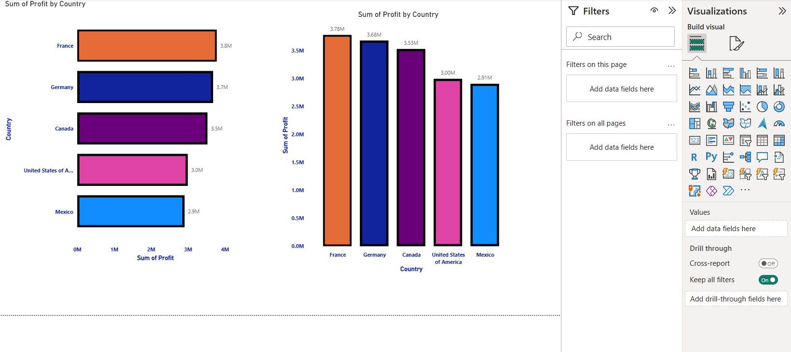

**Day 1 – Charts & Formatting**  
I learned how to create basic charts in Power BI and apply formatting to make them visually appealing. This included customizing colors, labels, titles, and adjusting chart layouts for better readability.